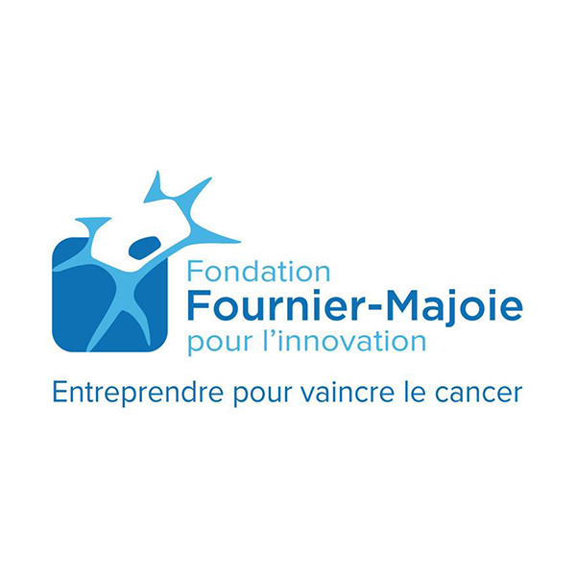

APPLICATION FORM

Cancer biomarkers, Functional Imaging,
Medical devices, Therapeutics, Platforms

General Information

Whenever applicable, an application should pertinently address the following criteria on which the evaluation will be based (weighting factor between brackets 1 Low-3 High):

- Unmet medical need that will be addressed (3)
- Management (3)
- Market potential/competitor advantage (3)
- Valorisation strategy (3)
- Technological validation or preclinical proof of concept (3)
- Intellectual Property (IP): at least a Freedom To Operate or strategy (3)
- Match funding secured or strategy to do so (2)
- Access to quality samples (retrospective studies) or clinicians (prospective studies) with a clear presentation of IP aspects related to such collaboration (3)
- Access to bio statistical expertise (2)
- Access to industrial assay/device development & testing skills: both internal quality control measures and external quality assurance (2)
- Regulatory strategy (2)
- Planning and budget accuracy (2)
- Risk appraisal (success/failure ratio) according to existing data (2)
- Competition mapping (2)

Application process:

Our preferred way of working can be subdivided in the following steps:

- A first contact by phone or e-mail (preferably) by the entrepreneur or the entrepreneurial researcher(s).
- Dedicated e-mail address for investment proposals: callforprojects@fournier-majoie.org
- An executive summary as a key document to capture our interest
- Presentation of the project plan (project funding) or the business plan (companies) to our management team, following the signature of a Confidential Disclosure Agreement
- Discussions on the project with different members of your team including visits to the Company / Research laboratory

EQUITY INVESTMENT | PROJECT FUNDING
- a term sheet summarizing the main terms and conditions of a potential investment  - due diligence process (including external expert advice)  - final closing requiring a shareholders and subscription agreement and eventual amendments of the articles of association | - expression of interest  - due diligence process (including external expert advice)  - a grant agreement including a revenue sharing principle  - a consortium agreement (in case of collaboration of more than one team belonging to different legal entities)
If you are applying for a project funding (Grant) please complete only PART 1
If you are applying of equity investments (equity or convertible loans) please complete only PART 2

PART 1 – PROJECT FUNDING - GRANT

ORGANISATION PROMOTING THE PROJECT

Name of organization/institution
Legal status
Year of creation
Purpose or mission
Address of head office
Street nr. & box
Postal code & locality
Tel
E-mail
Internet site
Stamp of organization/institution:

responsible Person (authorised to commit the organisation: Dean, Technology Transfer Office Director, CEO, CSO,…)

Name and forename
Gender | male – female
Function within the organization
Tel
Mobile
E-mail

Signature of responsible person:

PROJECT LEADER

Name and forename
Gender | male – female
Function within the organisation
Tel
Mobile
E-mail
Signature of project leader:

GENERAL INFORMATION ON THE ORGANISATION (for registered companies only)

Objective of the organisation
Activities of the organisation
Expertise of the organisation in relation to the project
Geographical scope of the organisation’s activities

SYNTHESIS OF THE PROJECT

Please fill out as clearly and fully as possible the sections ‘title’ and ‘description of project’. This information will in fact be included in all our communications (jury, annual report and website).

Project title
Short description of project
(5 lines max.)
Budget of the project | total budget:  support requested:
Duration of the project | date of beginning:  date of main milestones:  date of end:

EXISTING OR INTENDED COLLABORATIVE TEAMS (for example: clinical / surgical / anatomo-pathological teams, companies,…)

1.6.1. ORGANISATION

Name of organization/institution
Legal status
Year of creation
Purpose or mission
Address of head office
Street nr. & box
Postal code & locality
Tel
E-mail
Internet site
Stamp of organization/institution:

1.6.2. GENERAL INFORMATION ON THE COLLABORATIVE ORGANISATION (for registered companies only)

Objective of the organisation
Activities of the organisation
Expertise of the organisation in relation to the project
Geographical scope of the organisation’s activities

1.6.3. PROJECT LEADER IN THE COLLABORATIVE TEAM

Name and forename
Gender | male – female
Organization
Function within the organisation
Tel
Mobile
E-mail
Signature of project leader:

1.6.4. CURRICULUM VITAE

Please provide a curriculum vitae of the project leader and of the leaders in the collaborative team(s) together with the publications listing of the last 5 years.

PART 2 – FOR EQUITY INVESTMENT

2. EXECUTIVE SUMMARY
Please write a one-page summary including collaborative team(s) part

2.1. PROJECT DESCRIPTION
Please describe in maximum 5 pages and ensure that your answer takes into account the following aspects:

2.2 Business Plan
2.2.1. Problem & Solution
- Problem Worth Solving (Scientific relevance; medical need…)
- Your Solution
2. Novelty on Intellectual Property
3. Research and Development plan
- Methodology
- Preclinical Proof of Concept/validation of the technology
- Pre-Clinical and Clinical Investigation
4. Key Milestones/GANTT chart and Forecast
- Pre-Clinical and Clinical
- Production
- Sales expectations (Direct/Business Development/Licensing)
- Operations (Human Resources)
5. Target Market Potential
- Epidemiology, Incidence, patient population
- Market sales (National EU, US, Asia, ROW)
6. Competition
- Direct
- Indirect
7. SWOT Analysis
8. Company
- Overview
- Team
- Long-term vision
- Exit Strategy
9. Financial Plan
9.1 Revenues
- Business model
- Geographical presence
- Customer segmentation
- Customer base growth assomptions
- Licences
9.2 Cost of Goods & Services sold and Gross Margins
- Product profile
- Cost structure
- Expected cost of goods/services
- Gross Margin

9.3 Operational expenses
- Research and Development
- Sales & Marketing Expenses
- General & Administrative Expenses
- Total Operating Expenses and Operating Margin

Human Resources
Capital expenditures
Working Capital
Free Cash Flows
Financing
Other Assumptions

You can send your file by mail:
Fondation Fournier-Majoie pour l’Innovation
Avenue De Fré, 269/44
B - 1180 Brussels
Belgium
info@fournier-majoie.org

